21) When implementing linear regression of some dependent variable y on the set of independent.

variables 𝐱 = (𝑥₁, …, 𝑥ᵣ), where 𝑟 is the number of predictors, which of the following statements will

be true?

a) 𝛽₀, 𝛽₁, …, 𝛽ᵣ are the regression coefficients.

b) Linear regression is about determining the best predicted weights by using the method of ordinary least squares.

c) E is the random interval

d) Both a and b

Answer: d

22) What indicates that you have a perfect fit in linear regression?

a) The value 𝑅² < 1, which corresponds to SSR = 0

b) The value 𝑅² = 0, which corresponds to SSR = 1

c) The value 𝑅² > 0, which corresponds to SSR = 1

d) The value 𝑅² = 1, which corresponds to SSR = 0

Answer: d

23) In simple linear regression, the value of what shows the point where the estimated regression line crosses the y axis?

a) Y

b) B0

c) B1

d) F

Answer: b

24) Check out these four linear regression plots:

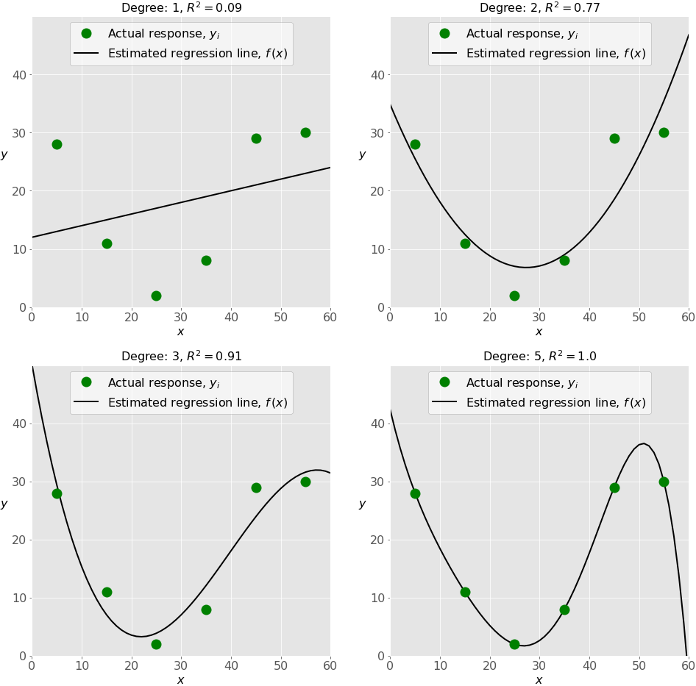

Which one represents an **underfitted** model?

a) The bottom-left plot

b) The top-right plot

c) The bottom-right plot

d) The top-left plot

Answer: d (lowest R2 value)

25) There are five basic steps when you’re implementing linear regression:

a)Check the results of model fitting to know whether the model is satisfactory.

b)Provide data to work with, and eventually do appropriate transformations.

c)Apply the model for predictions.

d) Import the packages and classes that you need.

e) Create a regression model and fit it with existing data.

However, those steps are currently listed in the wrong order. What’s the correct order?

a) e, c, a, b, d

b) e, d, b, a, c

c) d, e, c, b, a

d) d, b, e, a, c

Answer: d

26) Which of the following are optional parameters to Linear Regression in scikit-learn?

a) Fit

b) fit_intercept

c) normalize

d) copy_X

e) n_jobs

f) reshape

Answer: b,c,d,d

27) While working with scikit-learn, in which type of regression do you need to transform the array of inputs to include nonlinear terms such as 𝑥²?

a) Multiple linear regression

b) Simple linear regression

c) Polynomial regression

Answer: c

28) You should choose statsmodels over scikit-learn when:

A) You want graphical representations of your data.

b) You’re working with nonlinear terms.

c) You need more detailed results.

d) You need to include optional parameters.

Answer: c

29) _________ is a fundamental package for scientific computing with Python. It offers. comprehensive mathematical functions, random number generators, linear algebra routines, Fourier transforms, and more. It provides a high-level syntax that makes it accessible and productive.

a) Pandas

b) Numpy

c) Statsmodel

d) scipy

Answer: b

30 ) _________ is a Python data visualization library based on Matplotlib. It provides a high-level interface for drawing attractive and informative statistical graphics that allow you to explore and understand your data. It integrates closely with pandas’ data structures.

a) Bokeh

b) Seaborn

c) Matplotlib

d) Dash

Answer: b

41) Among the following identify the one in which dimensionality reduction reduces.

a) Performance

b) statistics

c) Entropy

d) Collinearity

**Answer: d**

42) Which of the following machine learning algorithms is based upon the idea of bagging?

a) Decision Tree

b) Random Forest

c) Classification

d) SVM

**Answer: b**

43) Choose a disadvantage of decision trees among the following.

a) Decision tree robust to outliers

b) Factor analysis

c) Decision Tree are prone to overfit

d) all of the above

**Answer: c**

44) What is the term known as on which the machine learning algorithms build a model based on sample data?

a) Data Training

b) Sample Data

c) Training data

d) None of the above

**Answer: c**

45) Which of the following machine learning techniques helps in detecting the outliers in data?

a) Clustering

b) Classification

c) Anamoly detection

d) All of the above

**Answer: c**

46) Identify the incorrect numerical functions in the various function representation of machine learning.

a) Support Vector

b) Regression

c) Case based

d) Classification

**Answer: a**

47) Analysis of ML algorithm needs

a) Statistical learning theory

b) Computational learning theory

c) None of the above

d) Both a and b

**Answer: d**

48) Identify the difficulties with the k-nearest neighbor algorithm.

a) Curse of dimensionality

b) Calculate the distance of test case for all training cases

c) Both a and b

d) None

**Answer: c**

49) The total types of the layer in radial basis function neural networks is ______

a) 1

b) 2

c) 3

d) 4

**Answer: b**

50) Which of the following is not a supervised learning

a) PCA

b) Naïve bayes

c) Linear regression

d) K Means

Answer: d